Game Design Document

Fill up the Following document

1. Write the title of your project.

Air Lines

1. What is the goal of the game?

To collect coins and escape from birds.

1. Write a brief story of your game?

An airplane loaded with passengers is on it’s way and is being given a challenge to collect all the coin in the journey and try not colliding with the birds.

1. Which are the playing characters of this game?

* Playing characters are the ones which respond to the user based on the input from the user
* Cars, monkeys, dinos, wizards etc, are the playing characters in the game.

|  |  |  |
| --- | --- | --- |
| Number | Character Name | What can this character do? |
| 1 | Airplane | This character can be controlled using the up and down arrow keys. |
| 2 |  |  |
| 3 |  |  |
| 4 |  |  |
| 5 |  |  |
| 6 |  |  |
| 7 |  |  |
| 8 |  |  |

1. Which are the Non Playing Characters of this game?

* Non Playing characters are the ones which don't have an action or a behaviour when the user interacts with the game.
* Hurdles, stones, bananas, coins, etc are non playing characters in the game.

|  |  |  |
| --- | --- | --- |
| Number | Character Name | What can this character do? |
| 1 | clouds | Will appear in the game randomly |
| 2 | birds | Will appear after certain frame counts ,the game will be over if they collide with the airplane |
| 3 | coins | Will increase the score |
| 4 |  |  |
| 5 |  |  |
| 6 |  |  |
| 7 |  |  |
| 8 |  |  |

Draw your imagination of this game. What does this game look like?

* Draw the game either on your computer or on paper,
* Add images of scenes of the game to show each of the playing and non-playing characters at least once.

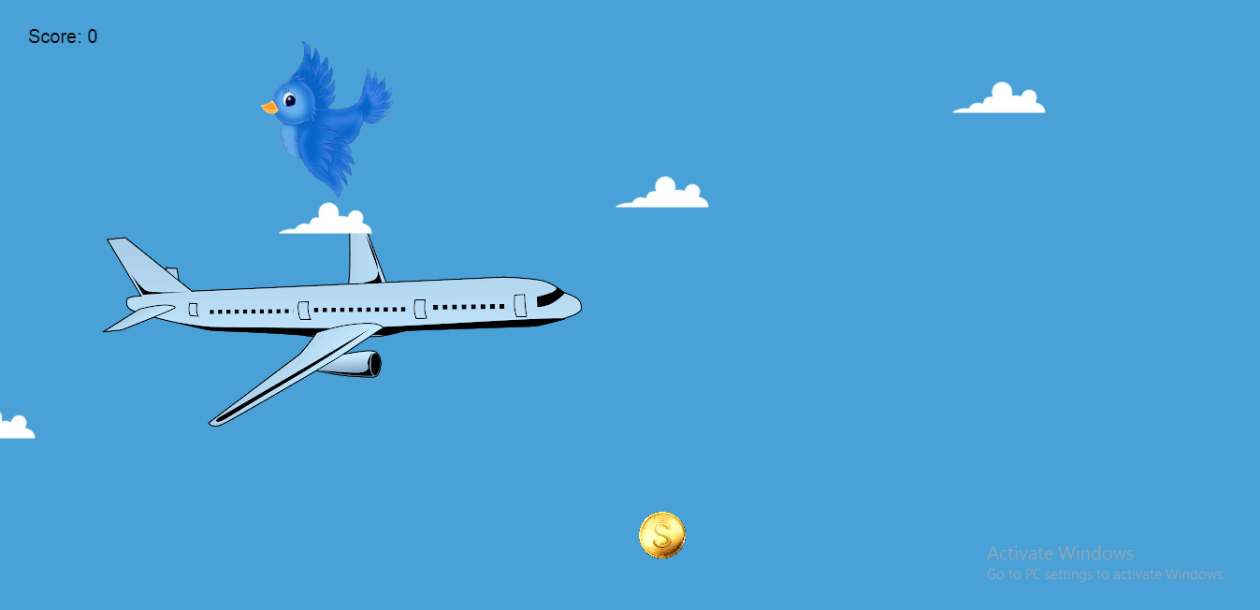

How do you plan to make your game engaging?

The speed increases as the score increases.